# Five9 MGR User Guide

General Information

Farm Move

MGR

Related Documents

**Description:** Provides frontline agents and their leaders an understanding of actions that Five9 can take when system issues occur as well as best practices in the event one of these actions occurs.

|  |
| --- |
| General Information |

When Five9 experiences an issue, there are two options available to restore service. The first being a farm move, which is the least impactful of the two options. The other option is to perform an MGR, which routes calls and agents to a new, healthy environment.

 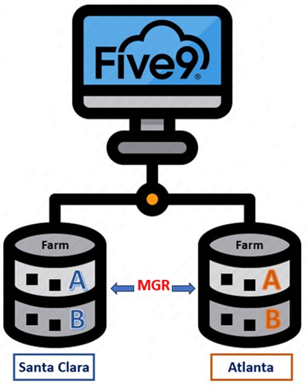

Top of the Document

|  |
| --- |
| Farm Move |

 The Five9 system consists of multiple “farms”, which are separate server environments that handle call processing. If there is an issue with the current farm, Five9 can move the agents and system functions to another farm that is working correctly.

**Agent Experience:** Calls in queue, including callbacks, will not be impacted. However, agents will experience the Five9 application reload. Agents will not be logged out and active calls will not be dropped.

Top of the Document

|  |
| --- |
| MGR |

The intent of an MGR is a controlled movement of calls and call agents to a new, healthy environment.

* During an MGR, the conference or transfer button within Five9 may not work.
* Callbacks are not impacted during an MGR, as members will still be given the option of a callback when hold times are high.

**Initiation:** An MGR is initiated with a timer, usually sixty (60) minutes.

**Timer Purpose:** The timer allows agents that can take calls to continue to work through the call volume that exists in the original queues. When the timer reaches five (5) minutes, agents on an active call will see a pop-up indicating that the application is about to restart. Agents should:

* Do their best to complete the call.
* Inform the member of the updates and ask them to call back if the call drops.
* Verify and document the member’s phone number.
* Document the account appropriately for the call.

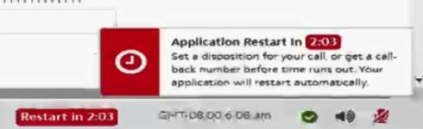

**Inbound Calls:** Once the timer is complete, the skilled agent for the Five9 application will automatically route inbound calls to the new environment. When the timer ends, all active calls, including calls in queue at the original environment, will be dropped.

**Agent Routing:** Any agents that log into Five9 after the MGR is initiated will also route to the new environment. Agents logged into Five9 prior to the MGR, including those on an active call, as well as calls in queue before the MGR, will remain in the original queue.

### MGR Best Practices

* When a MGR is initiated, it is imperative Five9 application users who are able to take calls remain logged in. This will allow agents to work through the queued calls and reduce the number of members impacted in the event the volume cannot be cleared before the timer ends.
* During the MGR, you may experience the application reloading. Allow this process to complete (it may take up to 5 minutes). Do not close the application while it is reloading as this will result in application errors.
  + During an MGR, you may experience any of the below symptoms or application errors:
    - Server Connection Lost:

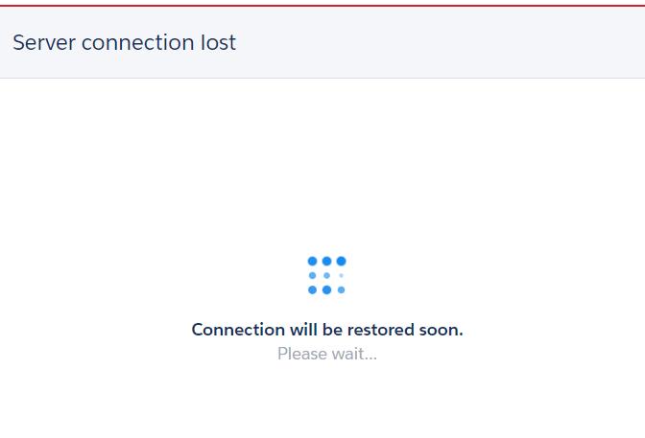

* + - Timed out waiting for response from server:

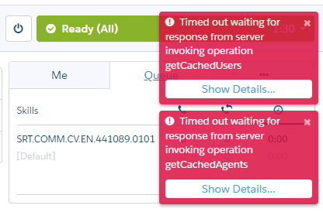

* + - Internal Server Error:

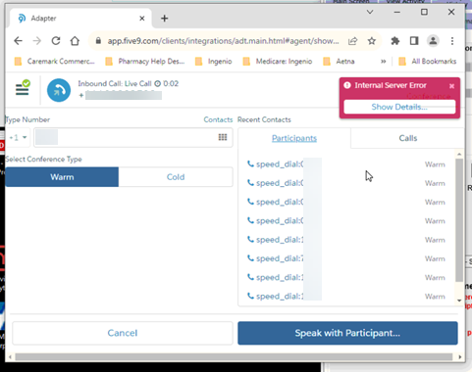

* + - Connection Problem:

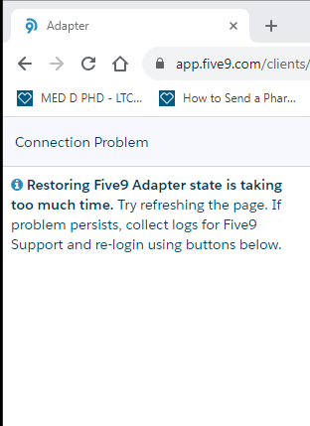

### Post MGR Troubleshooting:

 Ensure you have allowed 5 minutes to pass before proceeding to the next steps.

If issues persist after five (5) minutes, complete the following steps:

|  |  |
| --- | --- |
| **Step** | **Action** |
| **1** | Clear browser cache, cookies, and host application data in Chrome. Refer to [Clearing Your Cache (008655)](https://thesource.cvshealth.com/nuxeo/thesource/#!/view?docid=cd7acfcb-ad36-4da3-b973-faf08afb7dea).  Ensure the Hosted app data checkbox is checked when clearing cache. |
| **2** | Close all Chrome browser windows before attempting to open the Five9 application.   * + - If you continue to experience Five9 issues, complete a computer shut down.   **Note:** Do not perform a restart. You must select **shut down**.   * + If you continue to experience issues after shutting down, take a screenshot of the error(s) and send them to your leader along with your Network ID (The ID used to log in to your computer.). They will send these details to the CMO Incident Management team. |

Top of the Document

|  |
| --- |
| Related Documents |

[Five9 Document Index for Agents (052307)](https://thesource.cvshealth.com/nuxeo/thesource/#!/view?docid=e696b7c2-078e-444c-a317-bf857986aa23)

**Parent Documents:**[CALL 0049 Customer Care Internal and External Call Handling](https://policy.corp.cvscaremark.com/pnp/faces/DocRenderer?documentId=CALL-0049)

Top of the Document

Not to Be Reproduced or Disclosed to Others without Prior Written Approval

**ELECTRONIC DATA = OFFICIAL VERSION / PAPER COPY = INFORMATIONAL ONLY**